Home page project sections
One of the important features of EEZ Studio is that it enables the creation of projects for different target platforms using different technologies, which will be described below. The Projects section of the home page is shown in Fig. 1. which displays a searchable Recent Project List (RPL).

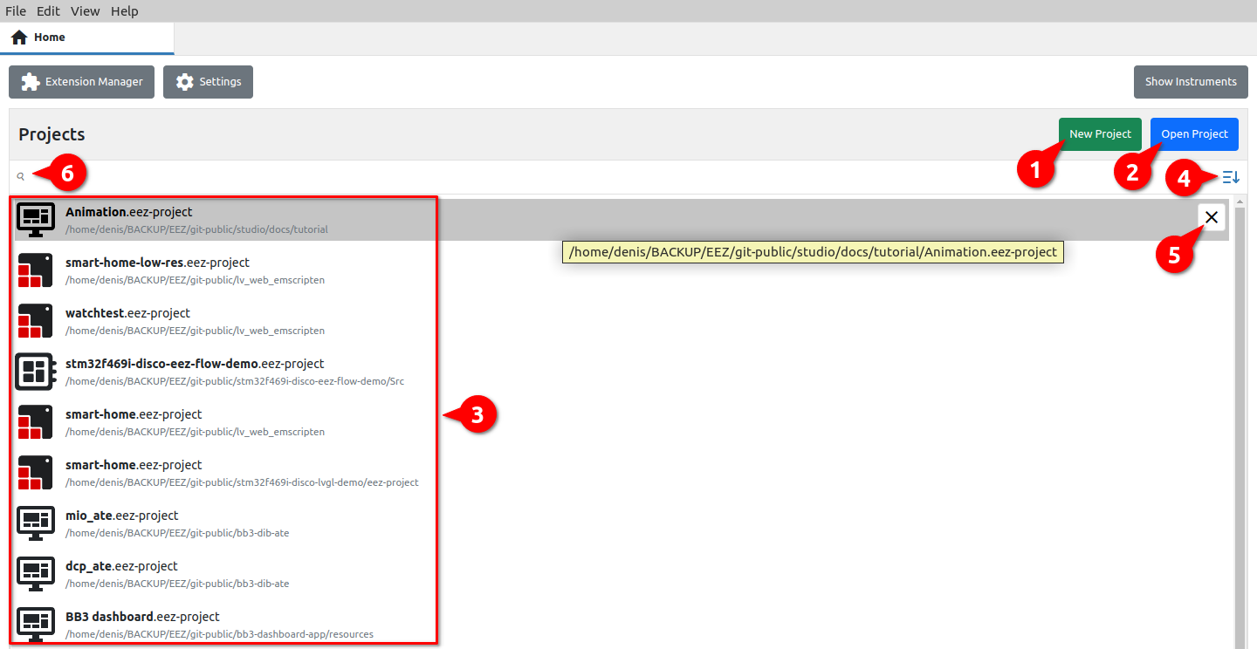Fig. 1: Home page project options
# | Option | Description
1 | New project | Creating a new project.
2 | Open project | Opening an existing project (will be added to RPL after successful loading).
3 | Recent Project List (RPL) | List of all successfully loaded projects after the first run.
4 | RPL sort order | Sorting order of projects in RPL: It can be Show most recent first or Sort alphabetically.
5 | Remove from RPL | Removing the project from RPL.
6 | Search RPL | RPL search by project name.

EEZ Studio project types
EEZ Studio offers the creation of the following project types:
- Dashboard – desktop application. GUI applications can be quickly and easily created thanks to the drag & drop of available widgets and the import of multiple fonts and ready-made bitmaps prepared by the designer. The animation editor allows adding simple animations to the desired sections of the page or navigation between pages. Finally, the flowchart method of defining program logic instead of programming in one of the programming languages will further speed up prototyping and creation of the final application. The implemented debugger will shorten the application development process and help in more efficient error detection.
- EEZ-GUI – embedded GUI application that uses the EEZ-GUI framework. This is a native EEZ Studio framework that was initially developed to speed up and simplify embedded GUI development for EEZ H24005 and EEZ BB3 firmware.
- LVGL – embedded GUI application that uses LVGL (Light and Versatile Graphics Library) framework. LVGL is a popular open source project that supports a large number of target platforms. For more information visit https://lvgl.io/
- Applet – GUI application that can be run on EEZ BB3. Program logic is created using EEZ Flow (flowchart-based programming).
- MicroPython script – GUI application that can be run on EEZ BB3. Program logic is created using MicroPython scripting.
- Templates from gitea repository – Completed projects located in the gitea.io repository (mostly based on the EEZ-GUI framework). They can be used as a starting point for creating new projects.
- Empty – Creating an empty project for advanced users who want to configure everything themselves from the start.

Create new project
When creating a new project, the first step is a dialog as shown in Fig. 2.

New project type
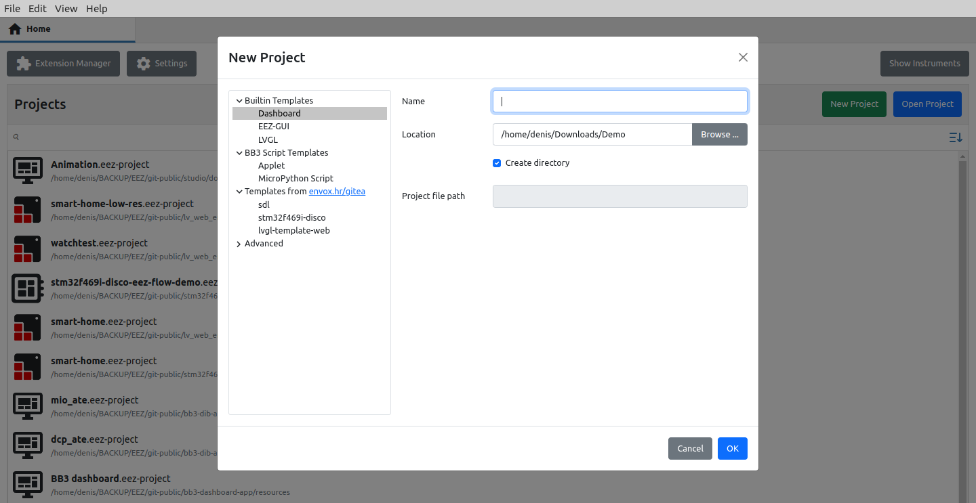Fig. 2: Create new project
List of available project types as mentioned in the previous section.

Name
The name of the new project.

Location
The location where the project files will be stored.

Create directory
If selected, a subdirectory (at Location) with the name of the project will be created.

Project file path
Information field (read-only) showing the resulting path in which the new project will be created.

Additional steps for creating EEZ BB3 projects
New Applet and MicroPython script projects require access to the EEZ BB3 firmware master project from which exported styles, fonts and themes are used to make the GUI of the newly created application compatible with the EEZ BB3 on which it will be executed.

The necessary EEZ BB3 master project can be downloaded from GitHub (Fig. 3) when creating a new project or set a reference to a local copy of the repository (Fig. 4).

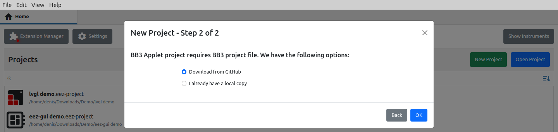Fig. 3: Selection of EEZ BB3 project for a new project from GitHub
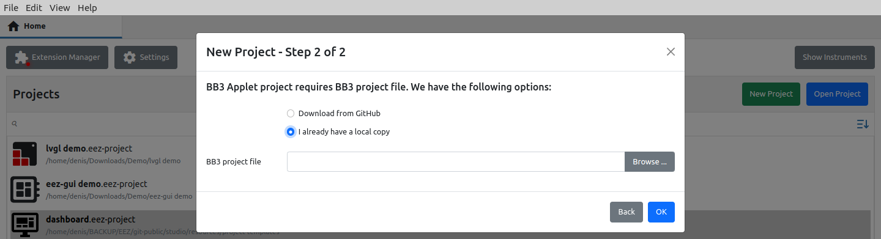Fig. 4: Selection of EEZ BB3 project for a new project from the local repository
When creating a MicroPython script project, it will be necessary in the third step to define which firmware version is used on the target EEZ BB3 in order to create the corresponding resource file during the build (Fig. 5).

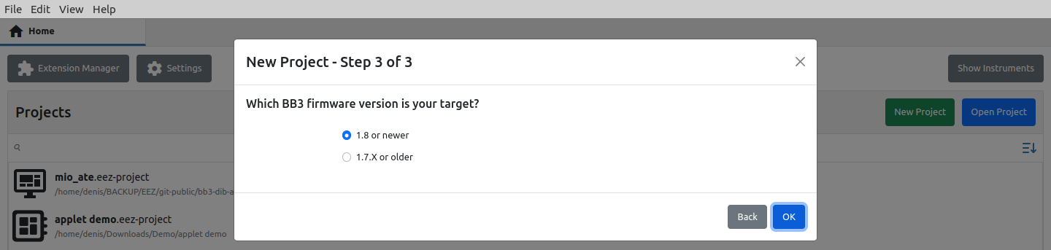Fig. 5: Selection of EEZ BB3 firmware version for a new project
After all steps have been confirmed, the new project will be displayed in the project editor in Edit mode. Fig. 6 shows a new project for the EEZ BB3 applet. An overview of the project editor can be found in the next chapter.

The newly created project has the minimum required to be able to execute it in simulation (Run or Debug mode) or after build on the target platform.

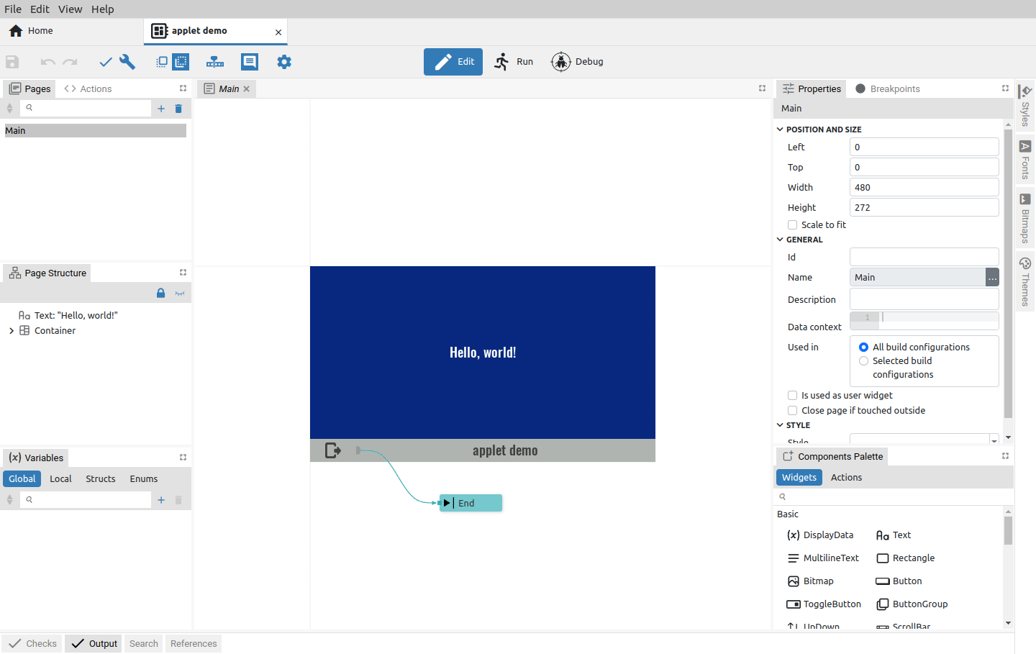Fig. 6: Newly created project in Edit mode
The basic project settings set by the New project wizard can be seen by clicking on the Settings option (1) when the project Settings will open in a new tab (2) as shown in Fig. 7.

There you can also see Project features that have been added and are mandatory, so the Remove option is disabled (3), added and can be removed (4) and others that have not yet been added (5).

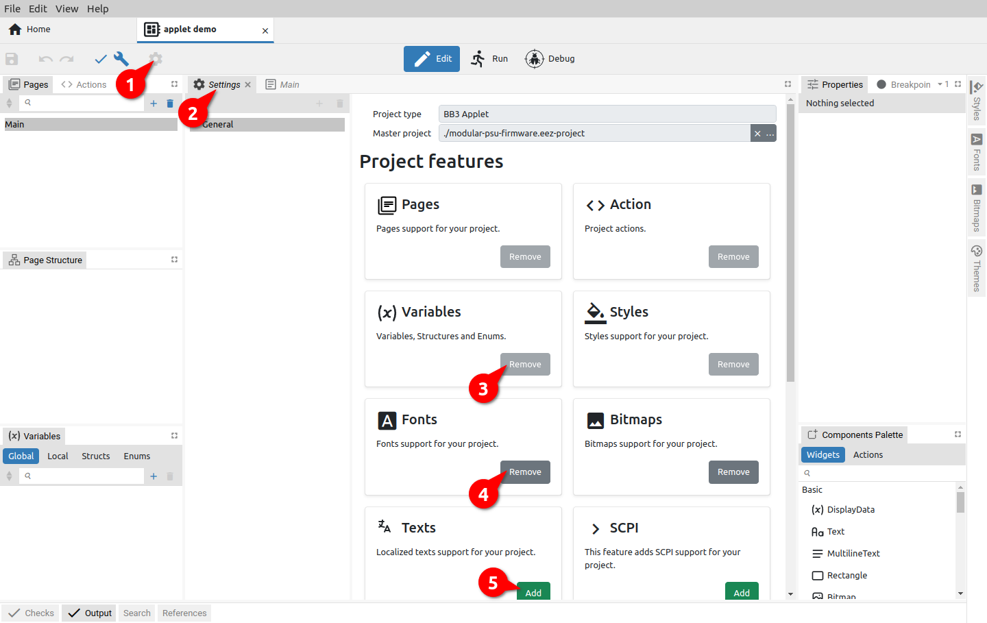Fig. 7: Newly created project settings

